**DAILY ONLINE ACTIVITIES SUMMARY**

|  |  |  |  |  |  |  |  |  |
| --- | --- | --- | --- | --- | --- | --- | --- | --- |
| **Date:** | **31/05/2020** | | | | | **Name:** | **Katira Krishna J** | |
| **Sem & Sec** | **8th A** | | | | | **USN:** | **4AL16CS045** | |
| **Online Test Summary** | | | | | | | | |
| **Subject** | | **IOT** | | | | | | |
| **Max. Marks** | | **20** | | **Score** | | | **19** | |
| **Certification Course Summary** | | | | | | | | |
| **Course** | **Machine learning with python** | | | | | | | |
| **Certificate Provider** | | | **Cognitiveclass.ai** | | **Duration** | | | **5 Hours** |
| **Coding Challenges** | | | | | | | | |
| **Problem Statement: Removing duplicate elements in list using python** | | | | | | | | |
| **Status: Completed** | | | | | | | | |
| **Uploaded the report in Github** | | | | | **yes** | | | |
| **If yes Repository name** | | | | | **Krishna_Katira** | | | |
| **Uploaded the report in slack** | | | | | **yes** | | | |

Online Test Details:

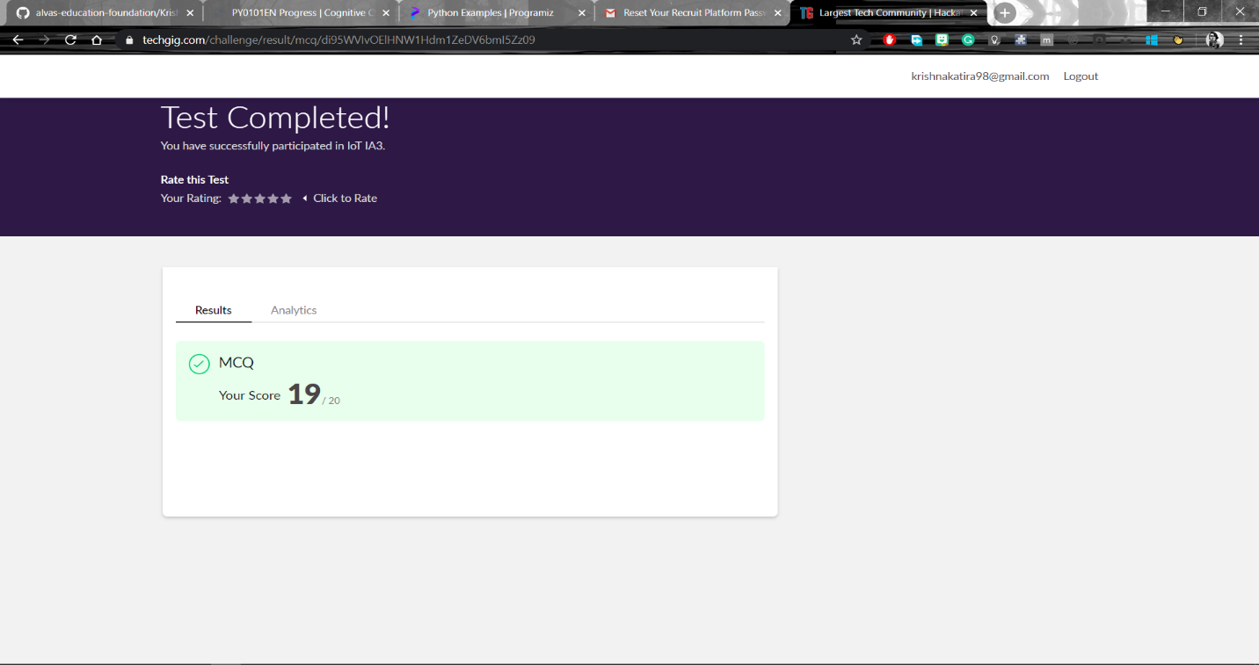

Certification Course Progress:

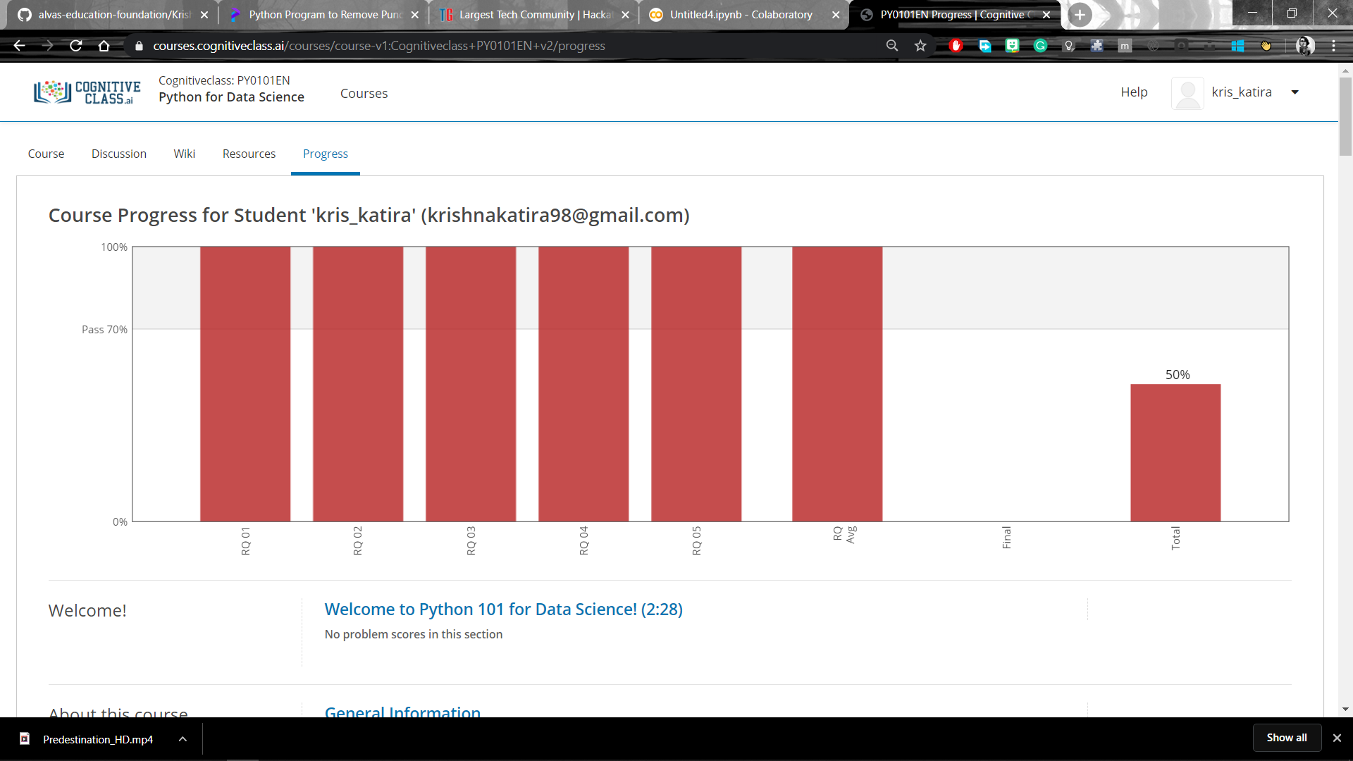

Coding Challenges Details:

**program1**

a=[]

n= int(input("Enter the number of elements in list:"))

for x in range(0,n):

element=int(input("Enter element" + str(x+1) + ":"))

a.append(element)

b = set()

unique = []

for x in a:

if x not in b:

unique.append(x)

b.add(x)

print("Non-duplicate items:")

print(unique)